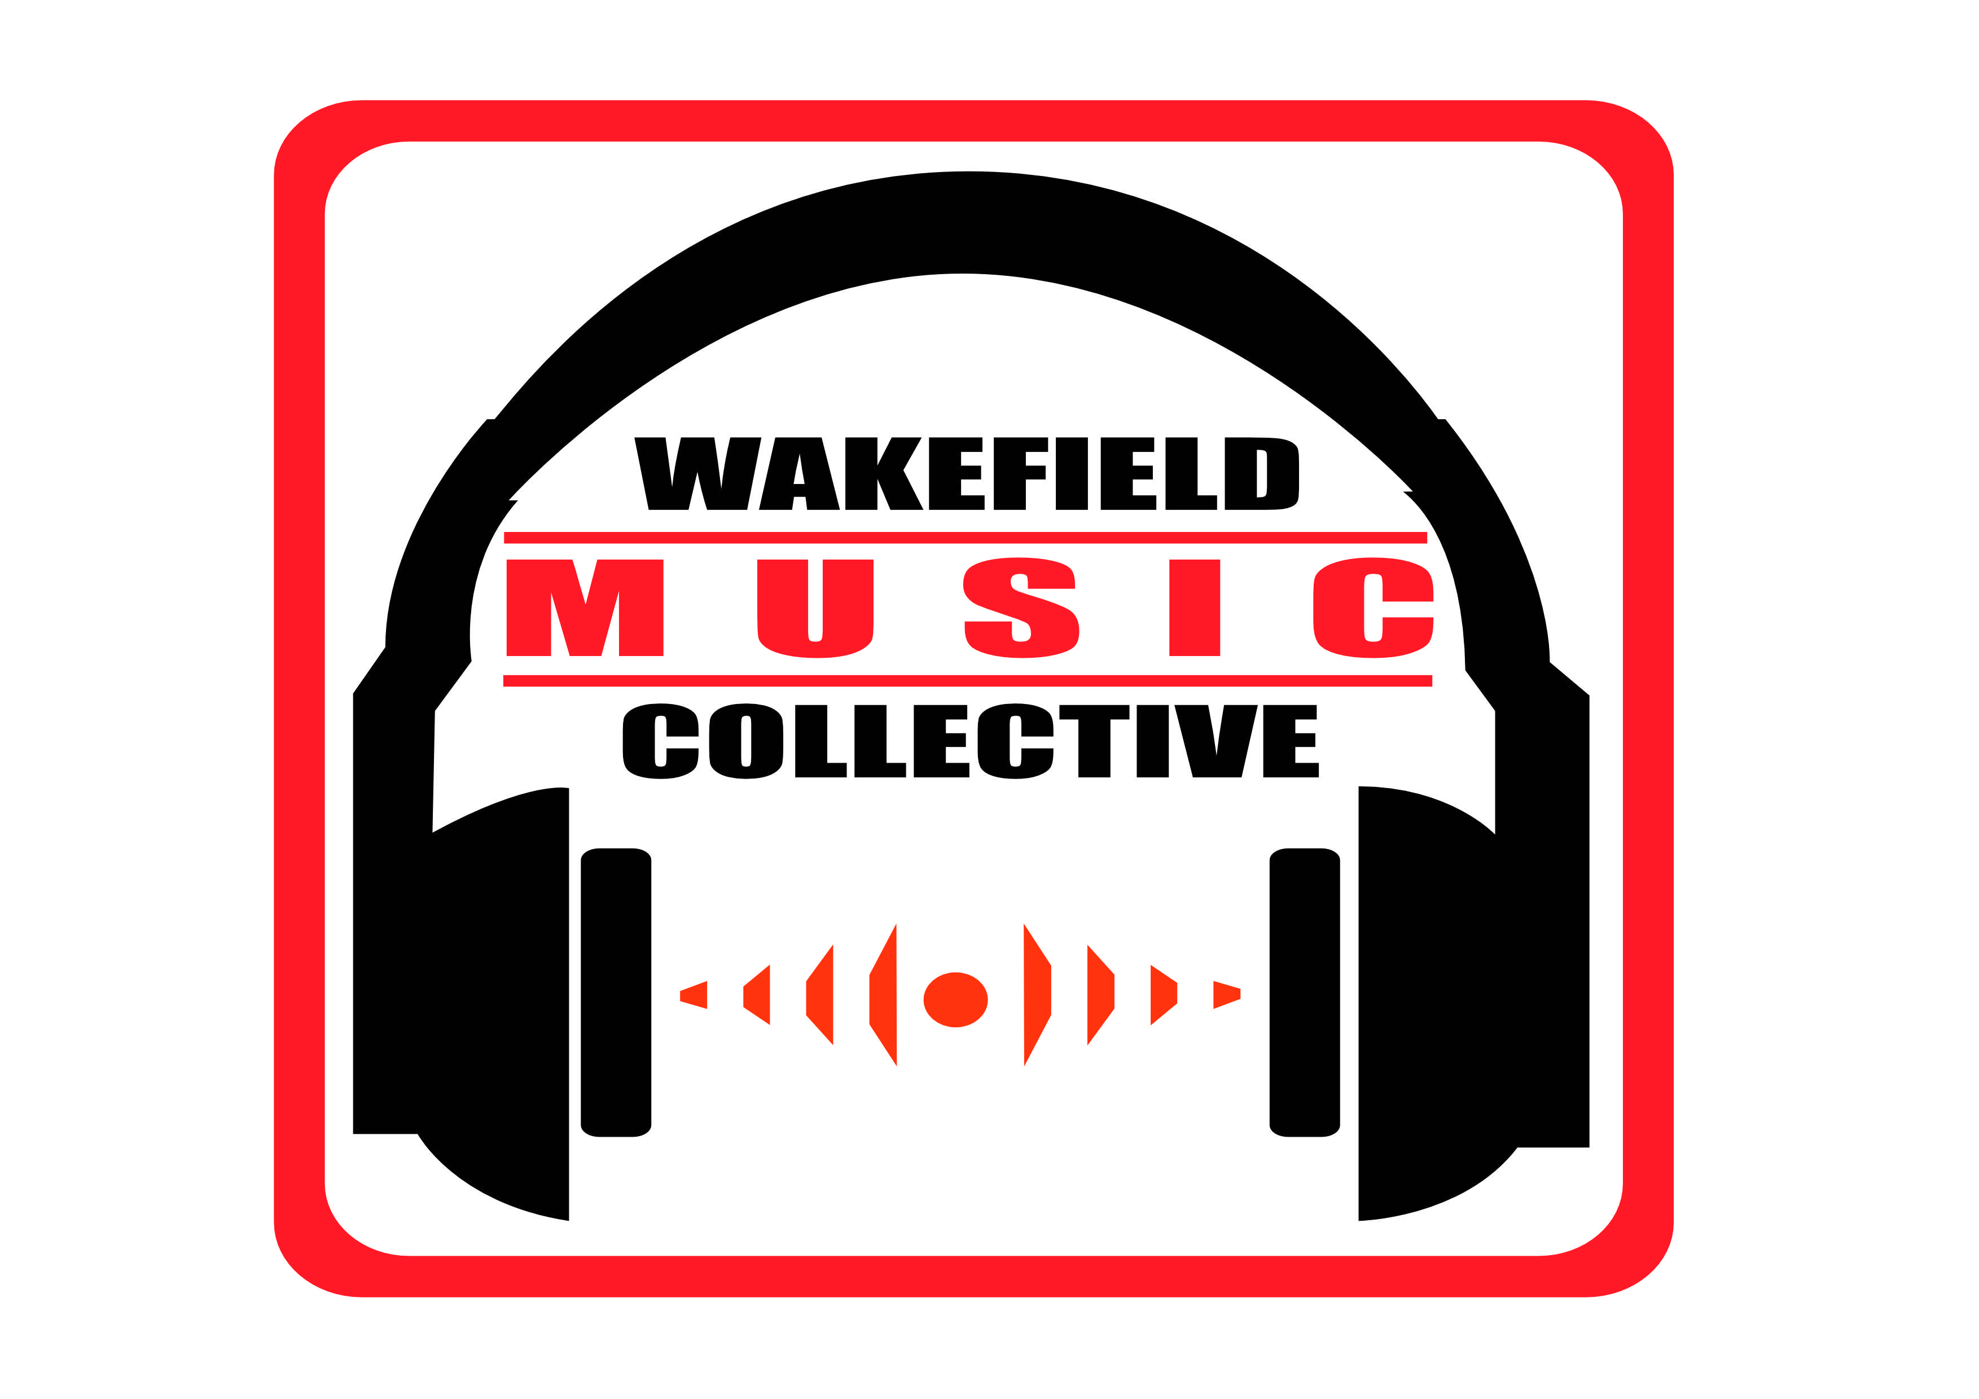
Clarence Golden Spirit 23

Yorkshire’s Longest Running Free Festival

Corporate Sponsorship
& Advertising
2023

Founded in 1991, Wakefield’s Clarence Park Music Festival is Yorkshire’s longest-running free outdoor music festival. Taking place over 2 days in Summer it has been known to regularly attract upwards of 5000 attendees.

In the past we’ve played hosts to acts from all over the world including Dodgy, Zodiac Mindwarp, Eddie & The Hot Rods, John Otway,The Solicitors, The Cribs’ first band Wrinkle, Malibu Stacey, Brick Supply, Germany’s own Faunshead and hundreds more!

Clarence Park Festival 2022 takes place on the weekend of 29TH and 30ST July 2023 at Clarence Park Bandstand, Denby Dale Road, Wakefield.

WHERE YOU COME IN...
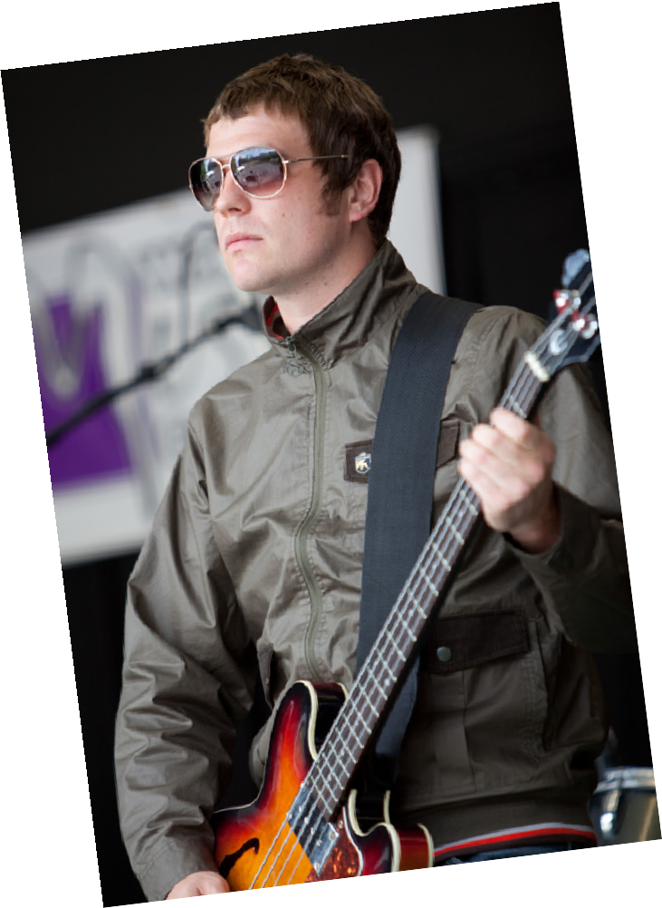
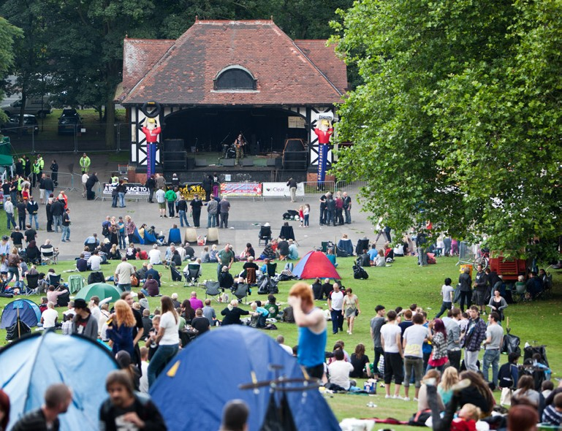
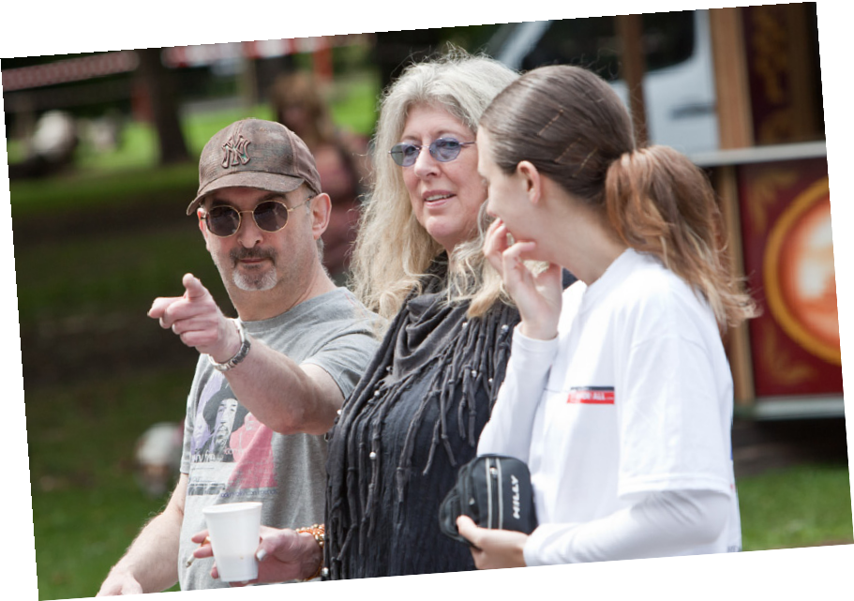
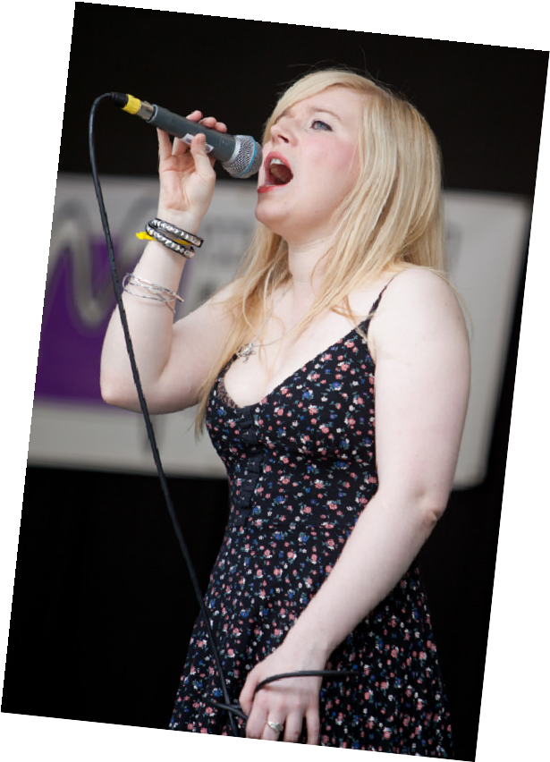
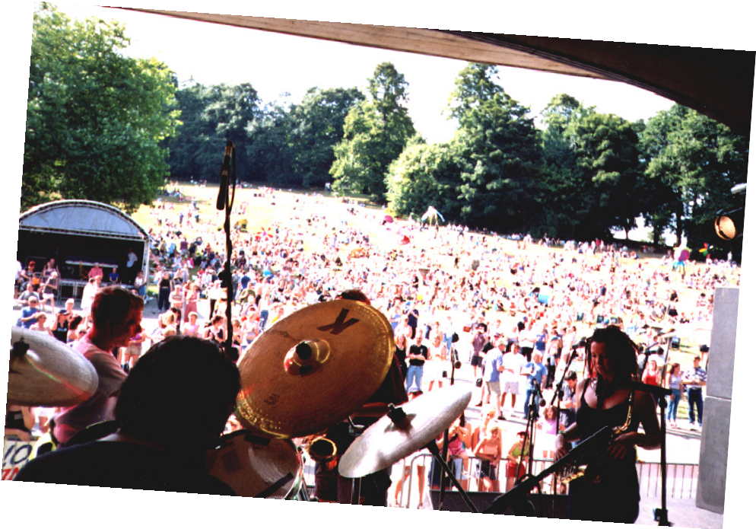
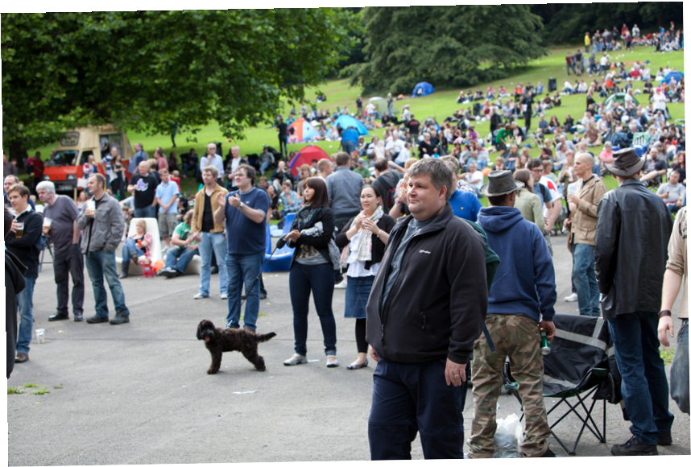
The Wakefield Music Collective are a not-for-profit volunteer run organization, therefore without help from our amazing sponsors the festival can’t happen! There are many opportunities to sponsor Clarence Park Festival and strengthen your brand by advertising to the thousands of people who regularly attend the festival over the weekend. These opportunities include programs, t-shirts, banners on-site, stage promotion, leaflets, and the Wakefield Music Collective website which can receive upwards of 10,000 visitors a day in the weeks up to the festival.

SPONSORSHIP PACKAGES

We’ve got a variety of out-of-the-box packages to suit lots of budgets.
Do you want to sponsor us but can’t find a package you’re looking for? Not a problem! Get in touch with us via email (info@themusiccollective.co.uk) or phone (07913 170445 or 01924 695060) and we’ll be happy to negotiate with you a package unique to you and your business.

Tier 1 Sponsorship - £250

Front-Of-House Banner Logo on poster
Quarter page in programme

Tier 2 Sponsorship - £500

Front-Of-House (fence) Banner Logo on shirt and poster
Half page in programme Logo on website

Tier 3 Sponsorship - £750

Front-Of-House (fence) Banner Logo on shirt and poster
Full page in programme Logo on website

Tier 4 Sponsorship - £1500

Front-of-House banner Stage banner
Full page in programme
2-page spread in programme A5 Insert in programme

Programme Sponsorship:

Thin bottom of page - £55 Quarter page - £75
Half page - £100 Full page - £150
Inside front cover - £250 Inside back cover - £250 Back cover - £400
Inserts in programme - £200

One-off Sponsorship Locations:

Performer/Steward hospitality area - £750
Toilet - £100 each
Headliner/support sponsorship - please ask

(One-offs subject to availability)

A limited number of stall pitches are also available Please enquire regarding availability and cost of stalls
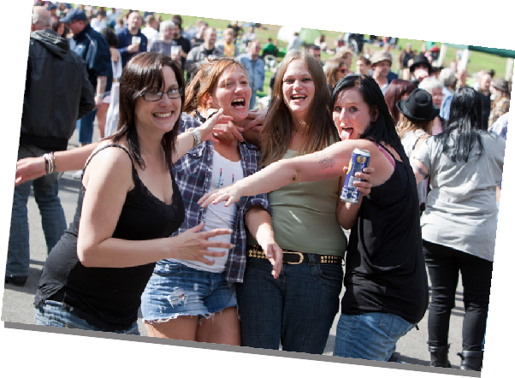
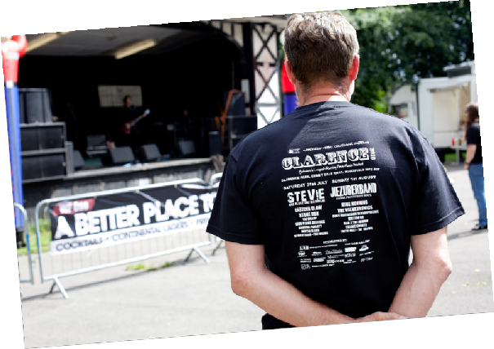
Banner sponsorship and leaflet inserts do not include production costs which must be borne by the sponsor. Artwork must be provided in camera-ready hi-resolution format by 20th June 2023.

WHERE DO I SIGN?

Complete the following and send it back to us to request your sponsorship package. We will be in touch as quickly as possible. Please note sponsorship deals are not final until we have received full payment.

Contact Name:

Company Name:

Address:

Email:

Website:

Contact Telephone Number:

Sponsorship Required:

Please return to: Wakefield Music Collective, 16 The Orchard, Ossett, WF5 8PP Telephone 07913 170445 or 01924 695060 or contact info@themusiccollective.co.uk

Wakefield Music Collective is a community group limited by guarantee and is not VAT registered, however we can provide a receipt for your sponsorship if required - please indicate above if you require this.

You can find out a lot more about Wakefield Music Collective on our website at:
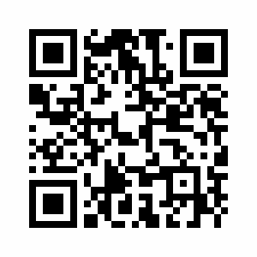
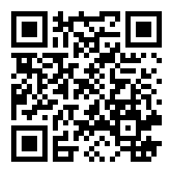
www.themusiccollective.co.ukor look for us on Facebook and Twitter

Our Facebook

Our Website

